**Manchester encoding**

application with a graphical user interface

**Manchester Encoding Application with Graphical User Interface - Code Review and Recommendations**

## Introduction

The Manchester Encoding Application provides a graphical user interface for encoding binary data using Manchester encoding. The application allows users to input binary data, visualize the Manchester encoding graphically, and encode data from a selected file.

## User Interface Components

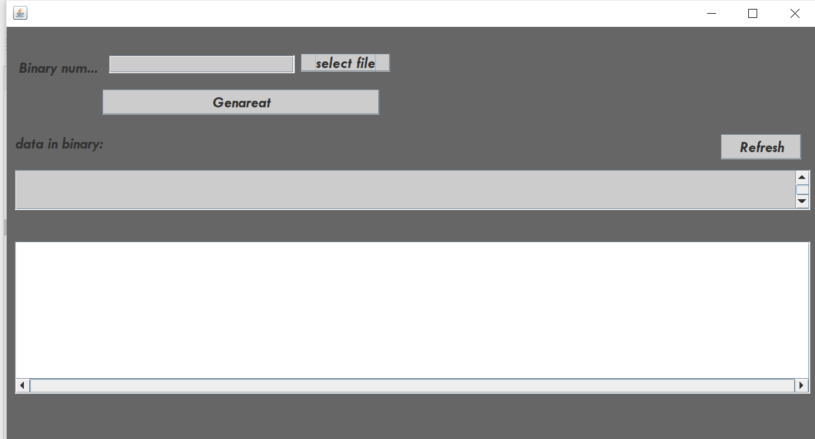The user interface consists of several components, including input fields, buttons, and a graphical display panel:

Binary Number Input

Binary Data Display

Graphics Panel users can input binary data through the **jTextField1** component. This text field allows users to type in a binary sequence directly. Here's how the user can input data:

**Binary Number Input Field (jTextField1)**

**users can choose to input data by selecting a file using the "Select File" button**

**Refresh (Optional):**If users want to start over or input new data, they can click the "Refresh" button .This clears the input field and graphical representation.

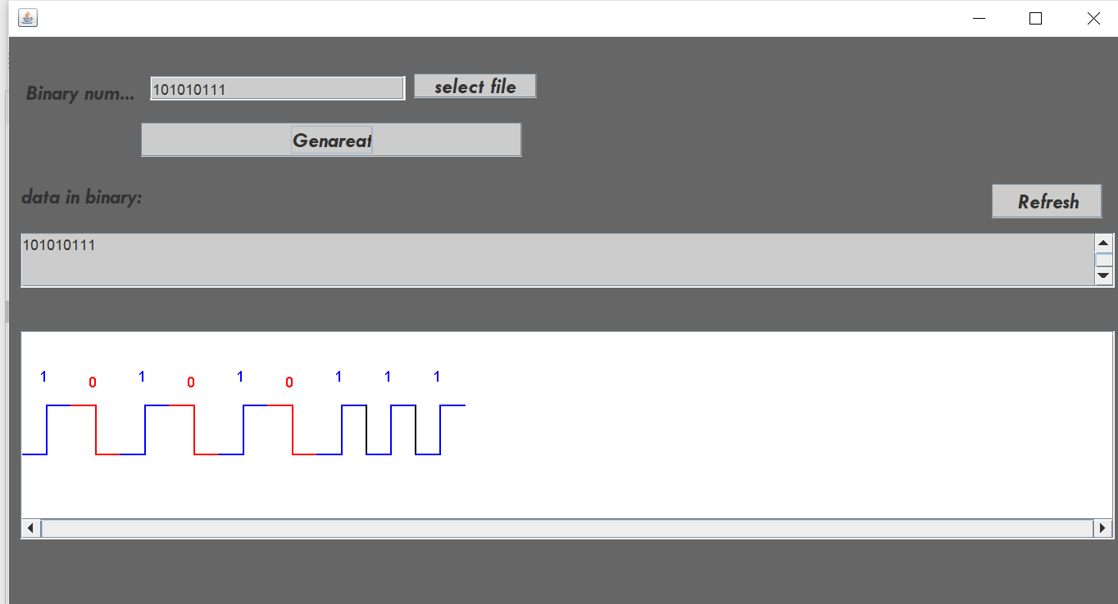

**Binary Number Input Field (jTextField1)**

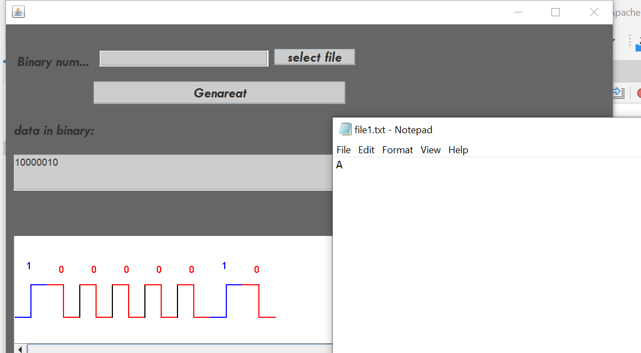

**Select File**